|  |  |
| --- | --- |
| Course Name | ITD 2313 – Script Programming |
| Instructor | Michael Schnell |
| Student Name | Samantha Ramsey |
| Due date | 3/12/23 |
| Grade | Put grade earned here |
| Grading Comments | Put instructor comments here |

# Pages 203-204

## Project # 5

### Special Instructions:

1. This project is to be done in a python program file. The file needs to be submitted as part of the submission for this assignment. Place the program file into the zip file that is submitted for this assignment.

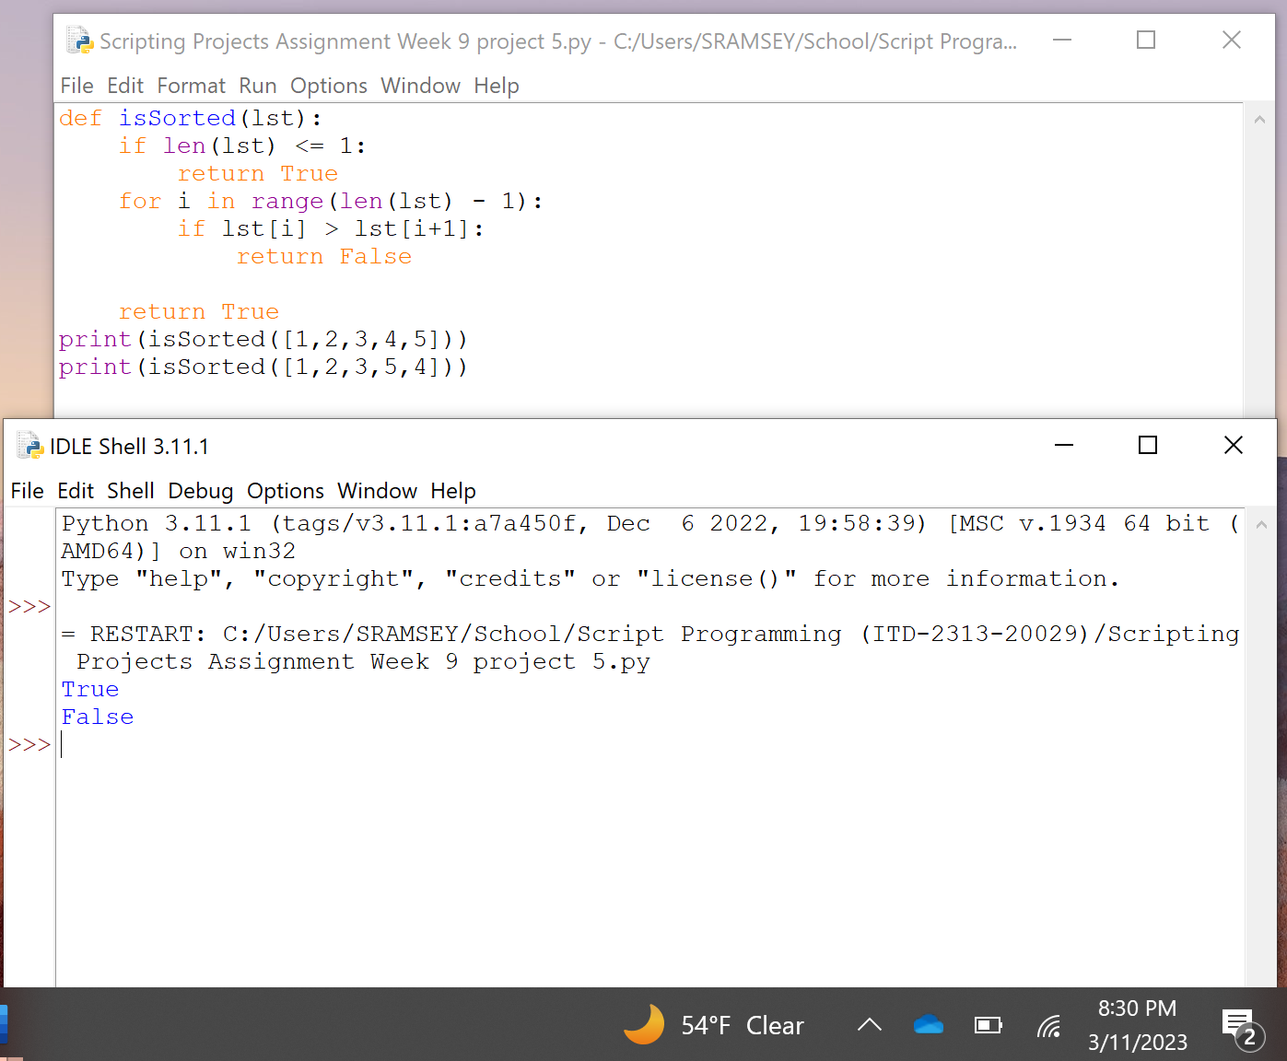

## Project # 8

### Special Instructions:

1. This project is to be done in a python program file. The file needs to be submitted as part of the submission for this assignment. Place the program file into the zip file that is submitted for this assignment.

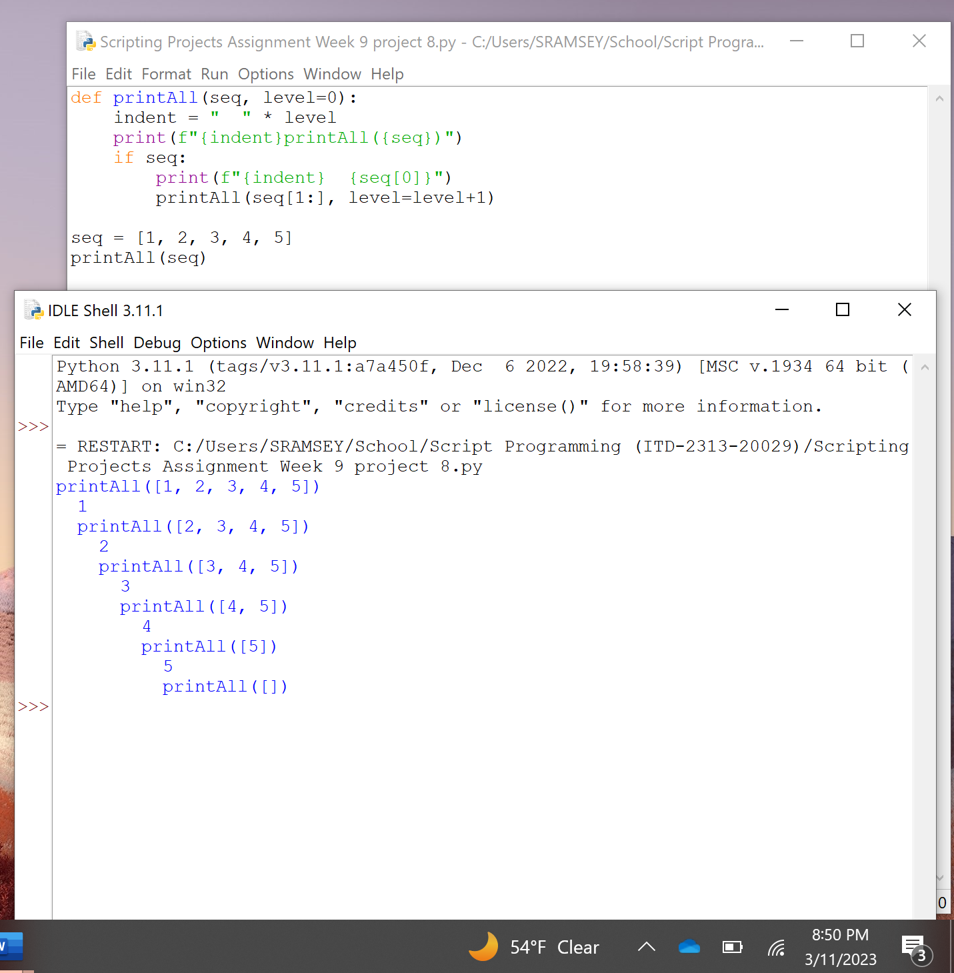

The function takes a sequence (string, tuple, or list) as its argument. It uses recursion because the sequence is empty. The function does nothing and just returns. When the sequence is not empty, the function prints the first element of the sequence using [seq0] and then calls itself recursively with the remainder of the sequence seq[1:]. This recursion will continue until the end is reached.

One hidden cost is that it creates a new slice of the sequence on each recursive call. This can increase the amount of time and memory that is used because it is so large.

## Project # 9

### Special Instructions:

1. This project is to be done in a python program file. The file needs to be submitted as part of the submission for this assignment. Place the program file into the zip file that is submitted for this assignment.

